A PRELIMINARY REPORT
ON

Title of Project

SUBMITTED TO THE SAVITRIBAI PHULE PUNE UNIVERSITY, PUNE
IN THE PARTIAL FULFILLMENT OF THE REQUIREMENTS
FOR THE AWARD OF THE DEGREE

OF

BACHELOR OF ENGINEERING (ARTIFICIAL INTELLIGENCE AND DATA SCIENCE)

SUBMITTED BY

STUDENT NAME EXAM SEAT NO:

Name of Student
Name of Student
Name of Student
Name of Student



DEPARTMENT OF ARTIFICIAL INTELLIGENCE AND DATA SCIENCE

DR. D.Y.PATIL INSTITUTE OF ENGINEERING, MANAGEMENT & RESEARCH

AKURDI, PUNE 411044

SAVITRIBAI PHULE PUNE UNIVERSITY
2025-2026
CERTIFICATE

This is to certify that the project report entitles

“TILE OF PROJECT”

Submitted by

STUDENT NAME EXAM SEAT NO
Name of Student
Name of Student
Name of Student
Name of Student

is a bonafide student of this institute and the work has been carried out by him/her under the supervision of GUIDE NAME and it is approved for the partial fulfillment of the requirement of Savitribai Phule Pune University, for the award of the degree of Bachelor of Engineering (Artificial Intelligence and Data Science).

Name of Guide Dr Suvarna Patil
Guide HOD
Department of Computer Engineering Department of AI&DS

Dr. Anupama V. Patil
Principal,
Dr.D.Y.Patil Institute of Engineering, Management & Research Akurdi Pune – 41

Place : Pune
Date :
ACKNOWLEDGEMENT

It gives us great pleasure in presenting the preliminary project report on ‘Project Title Name’.

I would like to take this opportunity to thank my internal guide Guide Name for giving me all the help and guidance I needed. I am really grateful to them for their kind support. Their valuable suggestions were very helpful.

I am also grateful to Dr Suvarna Patil, Head of Computer Engineering Department, Dr. D. Y. Patil Institute of Engineering, Management & Research for his indispensable support, suggestions.

In the end our special thanks to Mrs. Sneha Kanawade for providing various resources such as laboratory with all needed software platforms, continuous guidance, for Our Project.

Name of Student Sign

(BE Artificial Intelligence and Data Science)

ABSTRACT

Keywords:

TABLE OF CONTENTS

LIST OF ABBREVATIONS i
LIST OF FIGURES ii
LIST OF TABLES iii

Sr.No. |  |  | Title of Chapter |  | Page No.
01 |  |  | Introduction |  | 10
 | 1.1 |  | Overview |  | 10
 | 1.2 |  | Motivation |  | 10
 | 1.3 |  | Problem Definition and Objectives |  | 10
 | 1.4 |  | Project Scope & Limitations |  | 10
 | 1.5 |  | Methodologies of Problem solving
02 |  |  | Literature Survey |  | 12
03 |  |  | Software Requirements Specification |  | 15
 |  | 3.1 | Assumptions and Dependencies |  | 15
 |  | 3.2 | Functional Requirements |  | 15
 |  |  | 3.2.1 | System Feature 1(Functional Requirement)
 |  |  | 3.2.2 | System Feature2 (Functional Requirement)
 |  |  |  | ……
 |  |  |  | ……
 |  | 3.3 | External Interface Requirements (If Any)
 |  |  | 3.3.1 | User Interfaces
 |  |  | 3.3.2 | Hardware Interfaces
 |  |  | 3.3.3 | Software Interfaces
 |  |  | 3.3.4 | Communication Interfaces
 |  | 3.4 | Nonfunctional Requirements |  | 17
 |  |  | 3.4.1 | Performance Requirements
 |  |  | 3.4.2 | Safety Requirements
 |  |  | 3.4.3 | Security Requirements
 |  |  | 3.4.4 | Software Quality Attributes
 |  | 3.5 | System Requirements |  | 19
 |  |  | 3.3.1 | Database Requirements
 |  |  | 3.3.2 | Software Requirements(Platform Choice)
 |  |  | 5.3.3 | Hardware Requirements
 |  | 3.6 | Analysis Models: SDLC Model to be applied |  | 20
 |  | 3.7 | System Implementation Plan |  | 21
04 |  |  | System Design |  | 23
 |  | 4.1 | System Architecture
 |  | 4.2 | Data Flow Diagrams
 |  | 4.3 | Entity Relationship Diagrams
 |  | 4.4 | UML Diagrams
05 |  |  | Other Specification |  | 29
 |  | 5.1 | Advantages
 |  | 5.2 | Limitations
 |  | 5.3 | Applications
06 |  |  | Conclusions & Future Work |  | 30
Appendix A:

Problem statement feasibility assessment using, satisfiability analysis and NP Hard,NP-Complete or P type using modern algebra and relevant mathematical models.

Appendix B:

Details of the papers/Copyright. Summary of the Paper/copyright in not more than 3-4 lines. Here you should write the seed idea of the papers/ copyright you had referred for preparation of this project report in the following format.
Example:
Thomas Noltey, Hans Hanssony, Lucia Lo Belloz,”Communication Buses for Automotive Applications” In Proceedings of the 3rd Information Survivability Workshop (ISW-2007), Boston, Massachusetts, USA, October 2007. IEEE Computer Society.

Appendix C: Plagiarism Report

 |  |  | References

LIST OF ABBREVATIONS

Abbreviation | Ilustration
HTTP | Hyper Text Transfer Protocol
MQTT | Message Query Telemetry Transport

LIST OF FIGURES
Figure | Illustration | Page No.
1 | Waterfall Model | 21
2  3 | Timeline Chart  System Architecture | 23  24
4 | DFD Level – 0 | 25
5 | DFD Level – 1 | 25
6  7 | DFD Level – 2  ER Diagram | 26  26
8 | Use Case Diagram | 27
9 | Sequence Diagram | 28
10 | Collaborative Diagram | 28
11 | Deployment Diagram | 29
12 | Component Diagram | 29
13 | Class Diagram | 30
14 | State Chart Diagram | 30
15 | Activity Diagram | 31

LIST OF TABLES
Table | Illustration | Page No.
4.1 | Project Plan | 29

- INTRODUCTION

  - OVERVIEW
Nowadays, the most significant challenges in the stock market is to predict the stock prices. The stock price data represents a financial time series data which becomes more difficult to predict due to its characteristics and dynamic nature.
A stock market prediction is an attempt to forecast the future value of an individual stock, a particular sector or the market, or the market as a whole. These forecasts generally use fundamental analysis of a company or economy, or technical analysis of charts, or a combination of the two.

  - MOTIVATION
Stock price prediction is a classic and important problem. With a successful model for stock prediction, we can gain insight about market behavior over time, spotting trends that would otherwise not have been noticed. With the increasingly computational power of the computer, machine learning will be an efficient method to solve this problem. However, the public stock dataset is too limited for many machine learning algorithms to work with, while asking for more features may cost thousands of dollars every day.
We will introduce a framework in which we integrate user predictions into the current machine learning algorithm using public historical data to improve our results. The motivated idea is that, if we know all information about today stock trading (of all specific traders), the price is predictable. Thus, if we can obtain just a partial information, we can expect to improve the current prediction lot.
With the growth of the Internet, social networks, and online social interactions, getting daily user predictions is feasible job. Thus, our motivation is to design a public service incorporating historical data and users predictions to make a stronger model that will benefit everyone.

  - PROBLEM STATEMENT AND OBJECTIVE
Problem Statement:
To accurately predict the future closing value of a given stock across a given period of time in the future. Use different machine learning and deep learning models available and compare them in term of graphical analysis. The stock market prediction task is interesting as well as divides researchers and academics into two groups those who believe that the market is efficient and whenever new information comes up the market absorbs it by correcting itself, thus there is no space for predictions.

Objectives:
- The objective of the proposed work is to study and improve the supervised learning algorithms to predict the stock price.
- The system must be able to access a list of historical prices. It must calculate the estimated price of stock based on the historical data. It must also provide an instantaneous visualization of the market index

  - PROJECT SCOPE
Project Scope:
Analysis of stocks using data mining will be useful for new investors to invest in stock market based on the various factors considered by the software.

- LITERATURE SURVEY

Sr.  No | Paper Title | Journal Name | Authors &  Publication Date | Methodology
1 | Stock market analysis using machine learning |  | Kunal pahwa,  Neha Agarwal  16 Feb 2019 | Look at the raw data available to us and study it in-order to identify suitable attributes for the prediction of our selected label.  - Open-(Opening price of Stock)  - High-(Highest price possible at an instance of time)  - Low-(Lowest price possible at an instance of time)  - Close-(Closing Price of Stock)  Percentage Change(H/L) = High – Low *100/ Close  Percentage Change(O/C) = Close – Open*100/Open  We will be using SciPy, Scikit-learn and Matplolib libraries in python to program our model
2 | Survey on Sentiment Analysis based Stock Prediction using Big data Analytics |  | S. Naveen Balaji, P. Victer Paul, R. Saravanan .  2018 | - The major role of Big Data Analytics is to bind huge amount of statistical data to yield a precise output within a prescribed time limit  - Mapping the data using Hadoop or similar tools to reduce the volume of the data in cloud storage  - Random Walk Theory and Efficient Market Hypothesis are utilized. Data are gathered and prepared for sentiment analysis.  - Using Big Data Increased the time Complexity because of increment in Data Preparation
3 | Deep Learning Based Forecasting in Stock Market with Big Data Analytics |  | Gozde Sismanoglu,  Mehmet Ali Onde,  Furkan Kocer,  Ozgur Koray Sahingoz.  2018 | - Authors proposed a general framework that uses LSTM and CNN for heavy training to make high-frequency stock forecasting.  - In the LSTM layers where the neurons have their own memory, the past time data is stored and used in the development process of the model.  - LSTM structures have been developed to overcome the problem of vanishing / exploiting gradient.  - As a performance analysis Root Mean Squared Error (RMSE) calculated by the mathematical formula as shown in Equation – 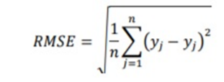
4 | The Application of Stock Index Price Prediction with Neural Network |  | Penglei Gao ,  Rui Zhang ,  Xi Yang.  18 August 2020 | - ANN could learn and generalize from experience with building complex neural network to deal with the non-linear relationships among complex time series, which makes it a good approximator in forecasting problems.  - LSTM schema cell works in 3 Layers  - Forget Layer  - Input Layer  - Output Layer  - Unlike ANN ,LSTM didn’t had any relationship issues
5 | An innovative neural network approach for stock market prediction |  | Xiongwen Pang, Yanqiang Zhou, Pan Wang,  Weiwei Lin,  Victor Chang.  2018 | The simplest method is the one-hot vector, which represents the position where the word appears as 1, and the rest is expressed as 0. But this method has two major drawbacks:  - The dimension of the word vector is equal to the size of the dictionary. But the size of the dictionary is so large that the dimension of the vector is large, thereby making calculation inconvenient.  - This representation cannot reflect the similarity between words, so it is not much of help for text processing and context semantic analysis.
6 | Support Vector Machines for Prediction of Futures Prices in Indian Stock Market |  | Shom Prasad Das,  Sudarsan Padhy.  March 2017 | The support vector machine has the following specific advantages over other machine learning methods for supervised learning:  - Training a support vector machine involves optimization of a convex function with linear constraint. This problem has a unique global minimum which in turn overcome strucking to local minima observed in neural network.  - The constructed model has an explicit dependence only on the support vectors, which reduces the computational cost.  - It scales relatively well to high dimensional data.
7 | Stock Market Prediction Performance of Neural Networks |  | Özgür İcan,  Taha Buğra Çelik.  October 15, 2017 | - . Financial prediction is one such field in which ANN is used alone or in combination with different machine learning techniques.  - Their results show that the neural network model can get better returns compared to conventional ARIMA models.
8 | CNN-based stock market prediction using a diverse set of variables |  | Ehsan Hoseinzade, Saman Haratizadeh.  20 March 2019 | - CNN took a one-dimensional input for making predictions only based on the history of closing prices while ignoring other possible variable.  - Since financial markets behavior is affected by many factors, it is important to gather related information as much as possible which was not done in the model
9 | Indices prediction of Bangladeshi stock by using time  series forecasting and performance analysis |  | Mujibur Rahman Majumder,  Imran Hossain,  Mohammad Kamrul Hasan.  9 February, 2019 | - ARIMA models are harmonized into time series data for predicting the coming point of the time series and for better perception of data.  - Holt-Winters smoothing is extensively used for predicting data that consist of seasonality, changing tendencies and seasonal interrelation but lags in accuracy
10 | Stock Price Prediction Using News Sentiment Analysis |  | Saloni Mohan, Sahitya Mullapudi, Sudheer Sammeta, Parag Vijayvergia, David C. Anastasiu.  2019 | - Facebook Prophet fit the model with the data consisting of stock prices of each company for the pervious years, in order to predict stock prices of each company for the next year  - overfitting and underfitting in Facebook Prophet with the help of a parameter called as changepoint prior scale, which is set at a default value of 0.005. So default value needs to calibrated every time the data set is changed

- SOFTWARE REQUIREMENT SPECIFICATION

  - INTRODUCTION
3.1.1 PROJECT SCOPE
    - The proposed system will help to predict the stock market prediction dataset.
    - The recommendation where given on the basis of dataset stock dataset.
    - The information shown on the application is only for the information purpose.
    - System has authority to maintain the application regularly.

    - USE CLASSES AND CHARACTERISTICS
Our system is divided into two class/modules:
1) user
2) system

    - ASSUMPTIONS AND DEPENDENCIES
- User must have the knowledge of web based application.
- User must have the knowledge of English.
- User must have all required software to run the application.

    - MATHEMATICAL MODELING
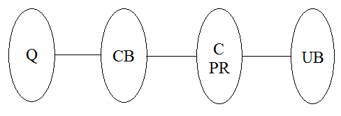
Figure 1 : Caption of Figure

Where,
Q = read the dataset
CB = preprocess
C= apply deep learning algorithm
PR= Preprocess request evaluation
UB = predict outcome

Set Theory
1) Let S be as system which input image
S = {In, P, Op,}
2) Identify Input In as
In = {Q}
Where,
Q = User entered input image(dataset)
- Identify Process P as
P = {CB, C, PR}
Where,
CB = preprocess
C = apply LSTM
PR = Preprocess request
4) Identify Output Op as
Op = {UB}
Where,
UB = predict outcome
=Failures and Success conditions.

Failures:
- Huge database can lead to more time consumption to get the information.
- Hardware failure.
- Software failure.
Success:
- Search the required information from available in Datasets.
- User gets result very fast according to their needs.

Space Complexity:
The space complexity depends on Presentation and visualization of discovered patterns. More the storage of data more is the space complexity.
Time Complexity:
Check No. of patterns available in the datasets= n
If (n>1) then retrieving of information can be time consuming. So the time complexity of this algorithm is O.

  - FUNCTIONAL REQUIRMENTS
- It should be able to predict stock price.
- It should be able to predict presence of intruder.
- Performance of the functions and every module must be well. The overall performance of the software will enable the users to work efficiently.
- The application is designed in modules where errors can be detected and fixed easily. This makes it easier to install and update new functionality if required.
- User information can only view by user himself/herself.

  - EXTERNAL INTERFACE REQUIREMENTS
- USER INTERFACES
The requirements section of hardware includes minimum of 180 GB hard disk and 4 GB RAM with 2 GHz or higher speed. The primary requirements include a memory of 4GB for the Android Application development and MySQL.

- HARDWARE INTERFACES
As this is an online application for product management we are not enabling or installing any hardware components for user interface.
It’s not an embedded system
    - Processor - Pentium IV 2.4 GHZ
    - Speed - 1.5 Ghz and Above
    - RAM - 4 GB (min)
    - Hard Disk - 220 GB
    - Key Board - Standard Windows Keyboard
    - Mouse - Two or Three Button Mouse

- SOFTWARE INTERFACES
This is the software configuration in which the project was shaped. The programming language used, tools used, etc are described here.
- Operating System : Windows
- Front End : html,css,boostrap,javascript
- Tool : Sublimetext3,pycharm
- Database : MySQL

- COMMUNICATION INTERFACES
- User can access the web application from remote location.
- Standard internet connection is required.
- TCP/UDP connection will be required.

  - NON-FUNCTIONAL REQUIREMENTS
- PERFORMANCE REQUIREMENTS
- High Speed:
System should process requested task in parallel for various action to give quick response. Then system must wait for process completion.
- Accuracy:
Sy System should correctly execute process, display the result accurately. System output should be in user required format.
- SAFETY REQUIREMENTS
The data safety must be ensured by arranging for a secure and reliable transmission media. The source and destination information must be entered correctly to avoid any misuse or malfunctioning. Password generated by user is consisting of characters, special character & number so that password is difficult to hack. So, that user account is safe.
- SECURITY REQUIREMENTS
Secure access of confidential data (user’s details).
    - Information security means protecting information and information systems from unauthorized access, use, disclosure, disruption, modification or destruction.
    - The terms information security, computer security and information assurance are frequently incorrectly used interchangeably. These fields are interrelated often and share the common goals of protecting the confidentiality, integrity and availability of information; however, there are some subtle differences between them.
    - User password must be stored in encrypted form for the security reason
    - All the user details shall be accessible to only high authority persons.
    - Access will be controlled with usernames and passwords.

- SOFTWARE QUALITY ASSURANCE
- Availability [related to Reliability]
- Modifiability [includes portability, reusability, scalability]
- Performance
- Security
- Testability
- Usability[includes self-adaptability and user adaptability]

  - SYSTEM REQUIREMENTS
- DATABASE REQUIREMENTS
MySQL : MySQL is an open-source relational database management system (RDBMS). Its name is a combination of "My", the name of co-founder Michael Widenius's daughter, and "SQL", the abbreviation for Structured Query Language.
MySQL is free and open-source software under the terms of the GNU General Public License, and is also available under a variety of proprietary licenses. MySQL was owned and sponsored by the Swedish company MySQL AB, which was bought by Sun Microsystems (now Oracle Corporation). In 2010, when Oracle acquired Sun, Widenius forked the open-source MySQL project to create MariaDB.
MySQL is a component of the LAMP web application software stack (and others), which is an acronym for Linux, Apache, MySQL, Perl/PHP/Python. MySQL is used by many database-driven web applications, including Drupal, Joomla, phpBB, and WordPress. MySQL is also used by many popular websites, including Facebook, Flickr, MediaWiki, Twitter, and YouTube.
- SOFTWARE REQUIREMENTS
Operating system : Windows 7 and above.
Coding Language : Python,
IDE : Sublimetext3 Pycharm
- HARDWARE REQUIREMENTS
System : Intel I3 Processor and above.
Hard Disk : 200 GB.
Monitor : 15 VGA Color.
Ram : 4 GB.

  - ANALYSIS MODELS : SDLC MODEL TO BE APPLIED

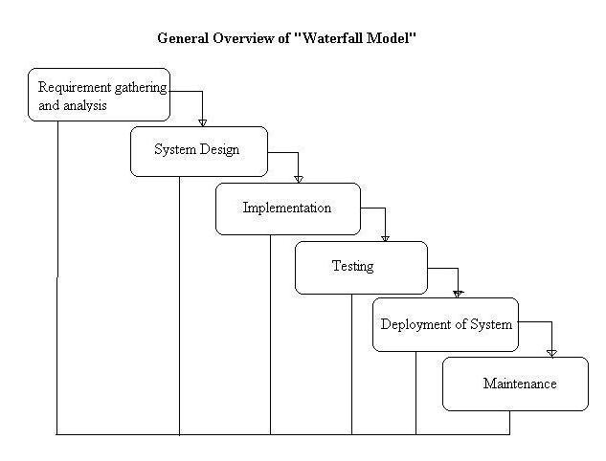

Figure 1 : Caption of Figure

  - SYSTEM IMPLEMENTION PLAN
1. Requirement gathering and analysis:
In this step of waterfall we identify what are various requirements are need for our project such are software and hardware required, database, and interfaces.

2. System Design:
In this system design phase we design the system which is easily understood for end user i.e. user friendly.
We design some UML diagrams and data flow diagram to understand the system flow and system module and sequence of execution.

3. Implementation:
In implementation phase of our project we have implemented various module required of successfully getting expected outcome at the different module levels.
With inputs from system design, the system is first developed in small programs called units, which are integrated in the next phase. Each unit is developed and tested for its functionality which is referred to as Unit Testing.

4. Testing:
The different test cases are performed to test whether the project module are giving expected outcome in assumed time.
All the units developed in the implementation phase are integrated into a system after testing of each unit. Post integration the entire system is tested for any faults and failures.

5. Deployment of System:
Once the functional and nonfunctional testing is done, the product is deployed in the customer environment or released into the market.

6. Maintenance:
There are some issues which come up in the client environment. To fix those issues patches are released. Also to enhance the product some better versions are released. Maintenance is done to deliver these changes in the customer environment.
All these phases are cascaded to each other in which progress is seen as flowing steadily downwards like a waterfall through the phases. The next phase is started only after the defined set of goals are achieved for previous phase and it is signed off, so the name "Waterfall Model". In this model phases do not overlap.

- SYSTEM DESIGN

  - SYSTEM ARCHITECTURE

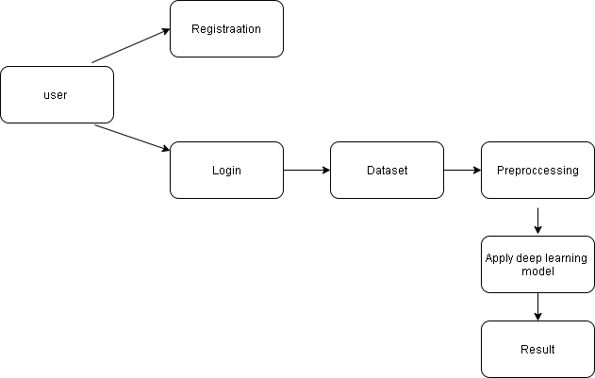
Figure 1 : Caption of Figure

  - DATA FLOW DIAGRAMS
DFD level 0

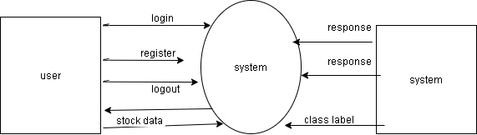

Figure 1 : Caption of Figure

DFD level 1

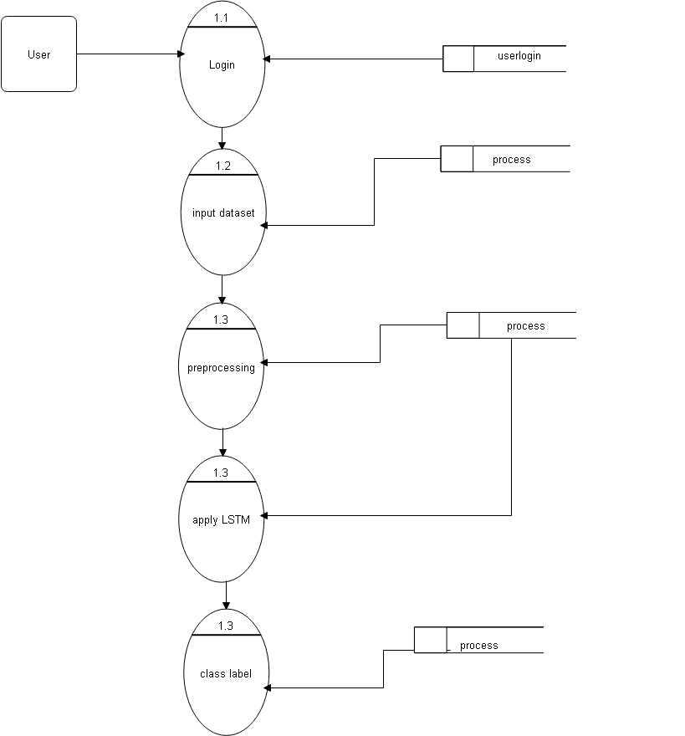

Figure 1 : Caption of Figure

DFD level 2

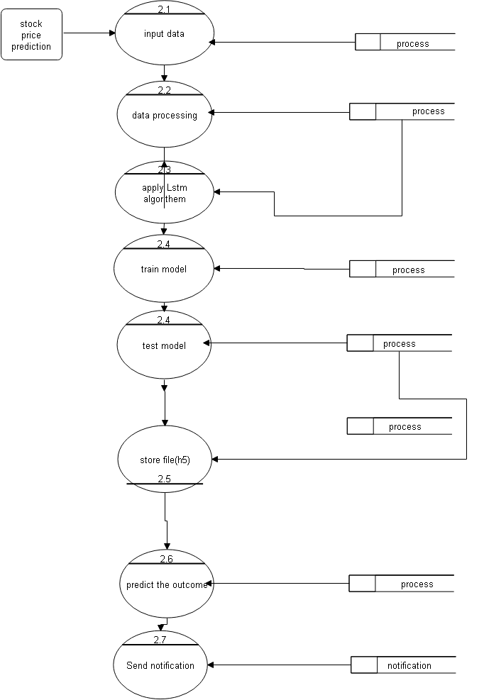

Figure 1 : Caption of Figure

  - ENTITY RELATIONSHIP DIAGRAMS

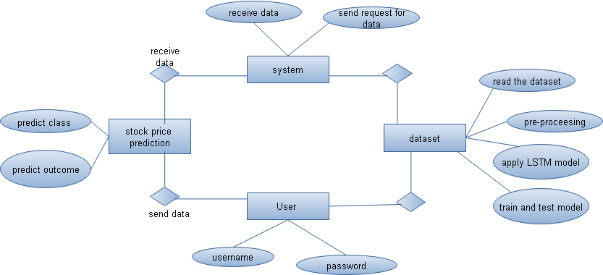

Figure 1 : Caption of Figure

  - UML DIAGRAM

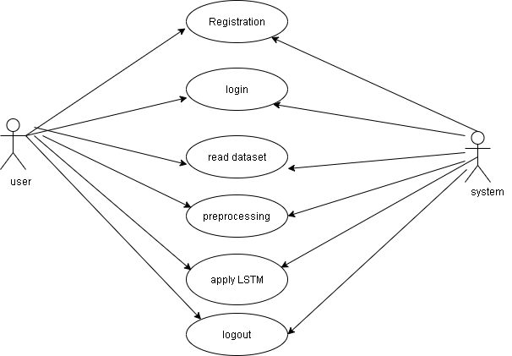

SEQUENCE DIAGRAM
Figure 1 : Caption of Figure

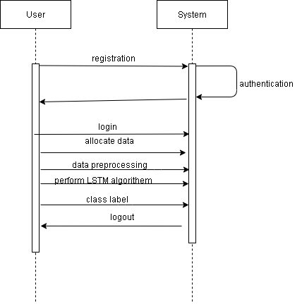

ACTIVITY DIAGRAM

Figure 1 : Caption of Figure

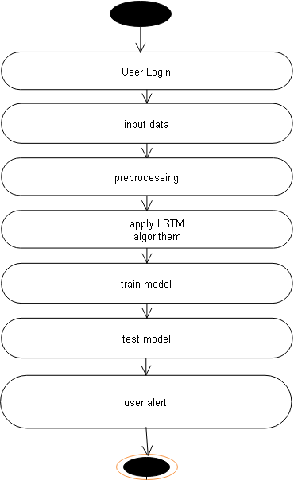

Figure 1 : Caption of Figure

- OTHER SPECIFICATION
5.1 ADVANTAGES
- Predict the stock price.
- Effective prediction technique
- Confirming those infected is essential to manage and contain the virus successfully. Without reliable testing, it would be hard to determine the actual rates of cases. Thus, it is vital to identify what these available tests can and can’t do to use them appropriately.
- Secure and efficient system

5.2 LIMITATIONS
- 1.User must have the knowledge of English.
- User must have all required software to run the application.
- It required internet connection must.
- The max operator has at least two disadvantages. Firstly, it is only suitable for the instance-level approaches that require an instance classiﬁer

- CONCLUSION & FUTURE WORK
Conclusion:
This project introduces the concept of time series analysis and forecasting in the perspective of Indian economy. The major downfall of the Indian rupee in the recent times has led to the critical need for stock market prediction so as to safe guards the interest of the investors. This project introduces the concept of time series analysis and forecasting in the perspective of Indian economy. The major downfall of the Indian rupee in the recent times has led to the critical need for stock market prediction so as to safe guards the interest of the investors. This project introduces the concept of time series analysis and forecasting in the perspective of Indian economy. The major downfall of the Indian rupee in the recent times has led to the critical need for stock market prediction so as to safe guards the interest of the investors.

Future scope:
- This research tries to analyze the time series data of the Indian stock market and build a statistical model that could efﬁciently predict the future stocks.
- This is mainly due to the reason that based on the forecasts the future strategies are developed. Short-term forecasting problems include predicting future events only up to a small time period.
- Helps in knowing the future cash needs and whether any additional borrowing is needed

References:
- Data Collection for Demand Forecasting. Accessed: Jul. 2018. [Online]. Available: http://www.economicsdiscussion.net/demand-forecasting/ data-collection-for-demand-forecasting/3583
- An Introduction to Indian Stock Market. Accessed: Jul. 2018. [Online]. Available: https://www.selfgrowth.com/articles/an-introduction-to-theindian-stock-market
- S. Rehman, I. U. Chhapra, M. Kashif, and R. Rehan, “Are stock prices a random walk? an empirical evidence of asian stock markets,” ETIKONOMI, vol. 17, no. 2, pp. 237–252, 2018.
- V. Atanasov, C. Pirinsky, and Q. Wang, “The efﬁcient market hypothesis and investor behavior,” 2018.
- S. Jain, M. Kain, and N. Singh, “Prediction for stock marketing using machine learning,” Bhagwan Parshuram Institute of Technology, p. 1, 2018.
- S. Sharma and B. Kaushik, “Quantitative analysis of stock market prediction for accurate investment decisions in future,” Journal of Artiﬁcial Intelligence, vol. 11, pp. 48–54, 2018
- S. Jain, M. Kain, and N. Singh, “Prediction for stock marketing using machine learning,” Bhagwan Parshuram Institute of Technology, p. 1, 2018
- S. Jain, M. Kain, and N. Singh, “Prediction for stock marketing using machine learning,” Bhagwan Parshuram Institute of Technology, p. 1, 2018
- S. Jain, M. Kain, and N. Singh, “Prediction for stock marketing using machine learning,” Bhagwan Parshuram Institute of Technology, p. 1, 2018
- S. Jain, M. Kain, and N. Singh, “Prediction for stock marketing using machine learning,” Bhagwan Parshuram Institute of Technology, p. 1, 2018
- S. Jain, M. Kain, and N. Singh, “Prediction for stock marketing using machine learning,” Bhagwan Parshuram Institute of Technology, p. 1, 2018
- S. Jain, M. Kain, and N. Singh, “Prediction for stock marketing using machine learning,” Bhagwan Parshuram Institute of Technology, p. 1, 2018

